Sun Mechanical Contracting, Inc. Sub Insurance Requirements (Attachment ‘A’) is made part of this questionnaire.
All subcontractors are required to complete this questionnaire to become a qualified Sun Mechanical subcontractor. The contents will be considered confidential and used solely to determine your firm’s qualifications.

E-mail this completed/signed form along with Evidence of Insurance per Attachment 'A' to: adminserv@sunmechanical.net

General Information
Legal Name of Business:
Address:
Remit to Address:
Phone Number:
Fax Number:
Website:
Primary Contact
Name/Title:
Phone Number:
E-mail Address:
Secondary Contact
Name/Title:
Phone Number:
E-mail Address:

Federal Employer ID Number: |  | Type of Company:  (Corp/LLC/Partnership, etc)
NAICS Classification: |  | Corporation Date:
SIC Classification: |  | Corporation State:
Principals
Name/Title:
Phone Number:
E-mail address:

Name/Title:
Phone Number:
E-mail Address:
Business Classification
Does your business meet a special classification: No Yes
If yes, please complete the remainder of the section and attach applicable documentation.
Minority Owned |  | Disadvantaged Business
Woman Owned |  | Service-Disabled Vet Owned
Small Business |  | Other:  ________________
Veteran Owned

Minority Certification Status: Self Private Public N/A

City: ____________________________________

State: ___________________________________

Work Classification
(Attach add’l info if needed)
Type of Work/Services Performed:
State Licenses:
Work Experience
(Attach add’l sheets if needed)
Major Projects- Last 2 Years
Project Name:
Location:
Contract Amount:
Contract With:
Contact Name:
Phone/e-mail:

Project Name:
Location:
Contract Amount:
Contract With:
Contact Name:
Phone/E-mail:

Project Name:
Location:
Contract Amount:
Contract With:
Contact:
Phone/E-mail:

Current Backlog
(Attach separate sheet if necessary)
Project Name | Contract Amount | Cost to Complete | Completion Date

Has your firm ever failed to complete any work awarded?

No Yes
Are there any judgments, claims, arbitrations, proceedings or suits pending or outstanding against your firm or its officers or principals?
No Yes
Has your firm filed any lawsuits or requested arbitration or mediation with regard to construction contracts within the last three years?
No Yes

Has your firm or any of its principals ever petitioned for bankruptcy, failed in business, defaulted or been terminated on a contract awarded to you?
No Yes
Have any of the owners, officers, or major stockholders of your Company ever been indicted or convicted of any felony or other criminal conduct?
No Yes
Has your firm ever been disbarred or otherwise precluded from pursuing public work or ever been found to be non-responsive to a public agency?
No Yes
Has your firm ever had a claim made against it for improper, delayed, defective, or noncompliant work or failure to meet warranty obligations?
No Yes
If yes to any of the above, please explain (attach add’l sheets if necessary):
Financial Information
Revenues
2015
2014
2013
2012

Bank
Name:
Address:
Contact Name:
Phone/E-mail:

Bonding
Surety name:
Agent-Company:
Address:
Contact Name:
Phone/E-mail:

Single Amount limit:
Aggregate Amount Limit:
Bond Rate:

Has your Company ever had any bond claims paid? No Yes
If, Yes, please explain: ____________________________________________________________________________________________________________________________________________________________________________________________________________________________________
Insurance
Your company must meet Sun Mechanical’s minimum requirements. Those requirements are listed on ‘Attachment A’ of this Prequalification Form.
Agent-Company Name:
Address:
Contact Name:
Phone/E-mail:

References
Suppliers
Company Name:
Contact Name:
Phone/E-mail:

Company Name:
Contact Name:
Phone/E-mail:

Company Name:
Contact Name:
Phone/E-mail:

Contractors
Company Name:
Contact Name:
Phone/E-mail:

Company Name:
Contact Name:
Phone/E-mail:

Company Name:
Contact Name:
Phone/E-mail:

Safety
Safety Contact:
Phone: |  | Email:

1. Does your company have a written Safety Policy and Program and will you provide a copy if requested?
No Yes

2. Does your company conduct safety inspections on all your projects?

No Yes Frequency: _____________________________

If yes, by (name/title): ______________________________________________________________________

3. Does your company have a new employee orientation?

No Yes

4. Does orientation include Appendix D with documentation that employee received?

No Yes

5. Does your company have a written substance abuse Policy?

No Yes
If yes, check which are included with policy:
Initial Employment For Cause Post Accident/Incident Random

6. Do you require documented safety meetings for all employees?

No Yes If yes, how often? Weekly Daily Or _____________________

7. Does your company have a disciplinary program for safety violations?

No Yes If yes, Verbal Written

8. Do you have a program for recognizing your employees for safety performance excellence?

No Yes

9. Has your company received any OSHA citations in the last 3 years?

No Yes

OSHA 300 Log | 2015 | 2014 | 2013
Number of Fatalities (Total Column G)
# of Cases with Days Away from Work (Total Col. H)
# of Restricted Workday Cases (Total Column I)
# of Other Recordable Cases (Total Column J)
Employee Hours Worked
OSHA Total Recordable Incident Rate
(total recordable injuries x 200,000 ÷ total hours worked)
OSHA Lost Time Incident Rate
(total lost workday cases x 200,000 ÷ total hours worked)
Experience Modification Rate (EMR)

This prequalification questionnaire was completed by:

Name/Title:
Phone: |  | Email:

Signature ________________________________________________________

Date: ___________________________________________________________

**The contents will be considered confidential and used solely to determine your firm’s qualifications.**

Sun Mechanical Contracting, Inc.
Vendor/Service Provider Insurance Requirements

This attachment defines the project insurance requirements for all projects incorporated by Purchase Order under the Master Subcontract Agreement, unless specifically modified by the terms of such Purchase Order for a specific project.

The Vendor/Service provider shall furnish evidence of insurance coverage prior to beginning work. Such insurance shall be with companies rated at least A-, VII by Best’s Rating Guide, and the insurance companies and policy forms shall be satisfactory to Sun Mechanical Contracting, Inc.

A. The Vendor/Service provider shall purchase and maintain in effect throughout the term of this contract the following insurance coverages:

1. Worker’s Compensation and Coverage A at statutory limits and coverage B at limits of $1,000,000/$1,000,000/$1,000,000. Insurance shall cover the employees of the Vendor/Service provider in compliance with the State of Arizona – and all other states having jurisdiction.

2. Standard ISO Commercial General Liability coverage, written on an occurrence basis and including Premises/Operations; Products/Completed Operation; Broad Form Property Damage; Contractual Liability; Coverage for Explosion, Collapse, and Underground Hazards; and Pollution Liability (if required by specific contract). The limits shall not be less than $1,000,000 for bodily injury and property damage for each occurrence and not less than $2,000,000 in the general aggregate and $2,000,000 products-completed operations aggregate.

3. Sun Mechanical Contracting, Inc. may require an Owners/Contractors Protective (OCP) Policy in Sun Mechanical Contracting, Inc.’s name with limits not less than $1,000,000 occurrence, $2,000,000 aggregate. In the absence of OCP, a per location/aggregate is needed.

4. Comprehensive Automobile Liability including owned, non-owned and hired vehicles with limits of not less than $1,000,000 for bodily injury and property damage for each occurrence.

5. Umbrella Liability with limits of not less than $2,000,000.

6. Waivers of subrogation if called for in the basic agreement

7. The Vendor/Service provider shall furnish Sun Mechanical Contracting, Inc. with satisfactory proof of insurance. Such proof shall consist of certificates executed by the respective insurance companies and filed with Sun Mechanical Contracting, Inc. If requested, the Vendor/Service provider will submit the original insurance policies for inspection by Sun Mechanical Contracting, Inc.

- Additional Insured endorsements must be attached to the certificate of insurance. The Additional Insured endorsement must include Completed Operations coverage in favor of Sun Mechanical Contracting, Inc. using ISO forms CG 20 10 (07/04) and CG 20 37 ( 07/04) or equivalent. On all policies except Worker’s Compensation, the Vendor/Service provider shall name Sun Mechanical Contracting, Inc. as an additional insured for all liability described in this contract.

- All policies in which Sun Mechanical Contracting, Inc. is named as an Additional Insured shall include the following “Other Insurance” endorsement: “All Liability policies shall be endorsed as Primary and non-contributory as to any insurance maintained by Owner or Sun Mechanical Contracting, Inc.”.

- Each policy shall contain a provision obligating the insurer to give Sun Mechanical written notice of cancellation or non-renewal not less than thirty (30) days prior to the effective date of cancellation or non-renewal.

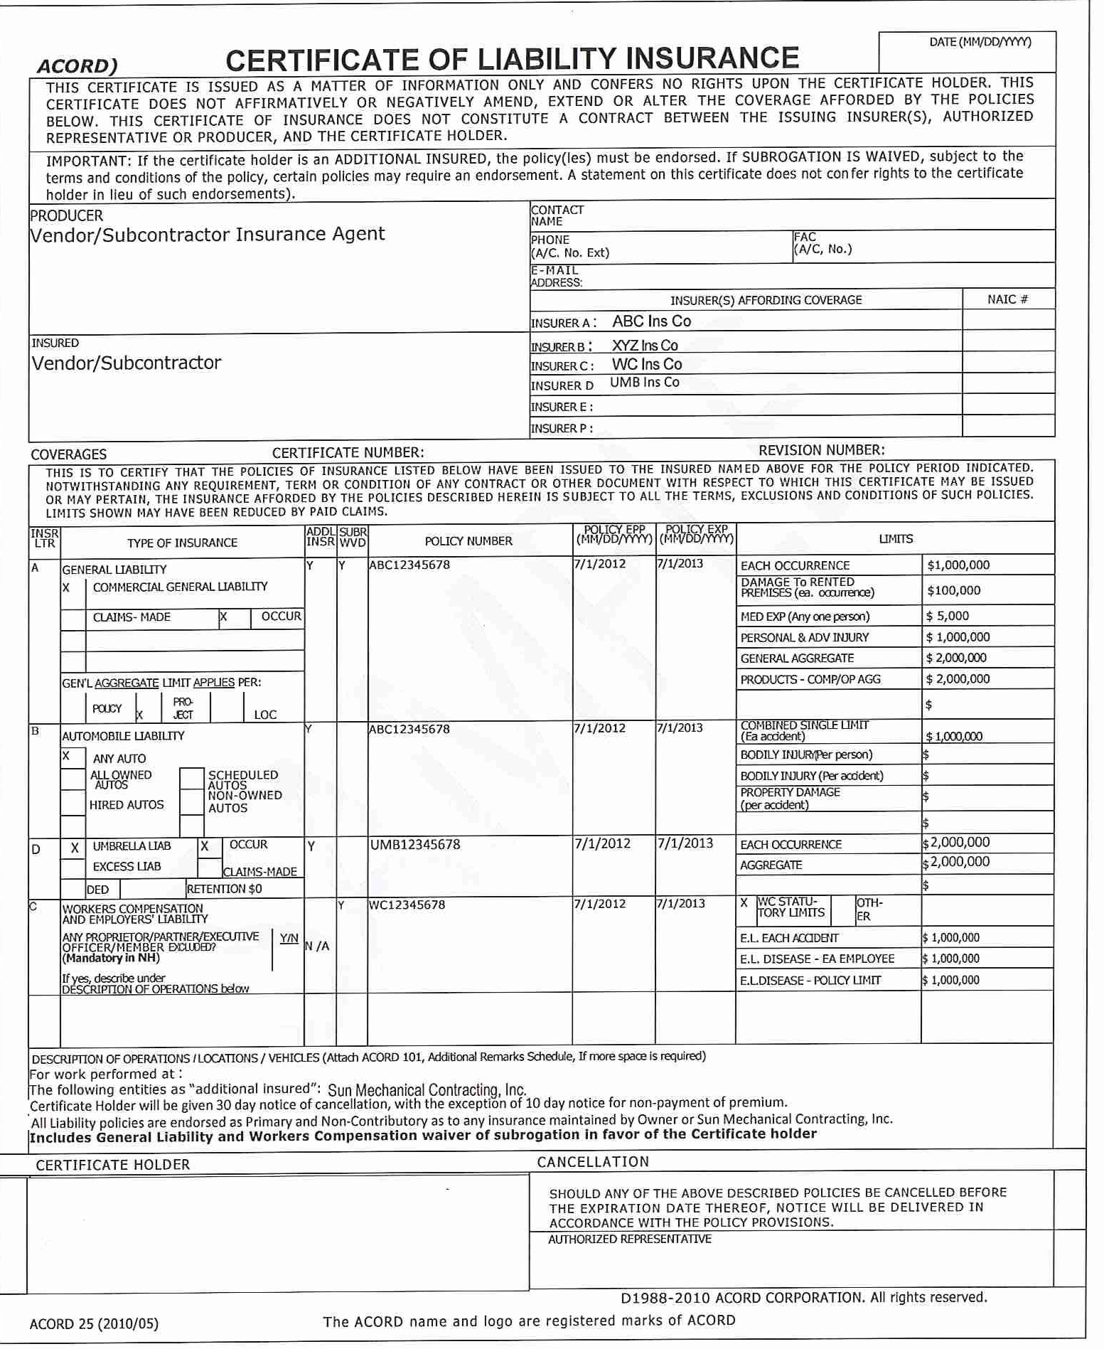
Sun Mechanical Contracting, Inc
3951 E. Columbia St.
Tucson, AZ 85714

